1.Create a table name STUDENT with following structure.
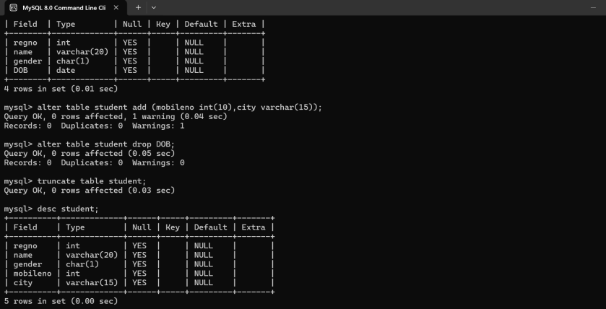
2. Create a table name FACULTY with following structure.
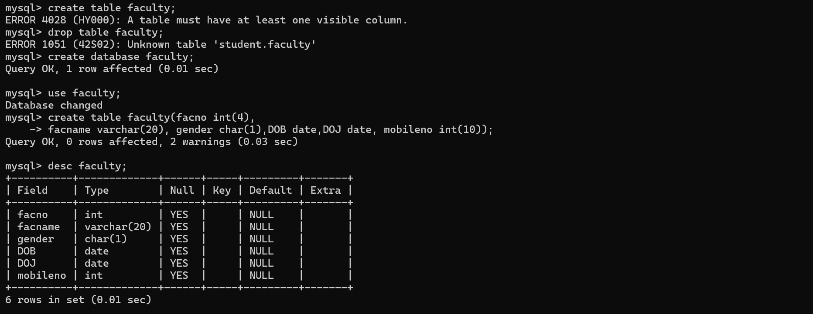

3.Create a table name DEPARTMENT with following structure.
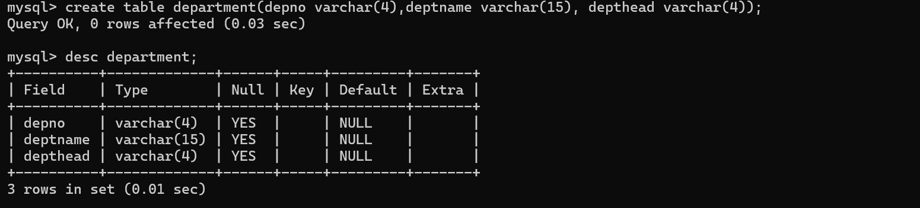

4. Create a table name COURSE with following structure.
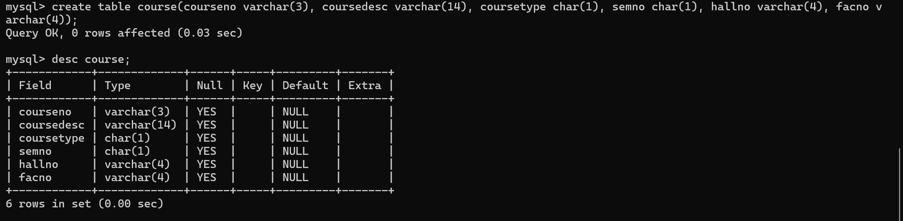
5.Modify the table FACULTY by adding a column name Dept of datatype VARCHAR(10)
